Town Manager  Tax Collector  Town Clerk  Assessor |  | Police Department  Fire Department  Code Enforcement  Sewer Department
Complete Your Deck: Use the sample typical deck framing plan shown below and the requirements of this document to complete your deck.

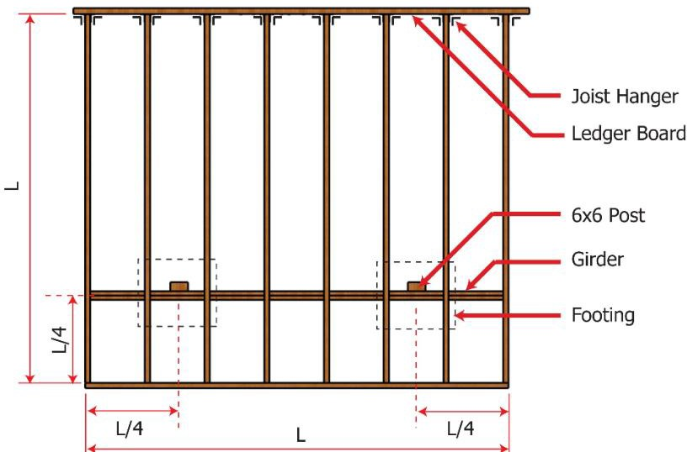
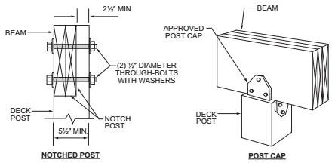

Deck Size: Length = ft. - in. Width= ft.- in. Height off ground ft.- in.
L/W= < 2.0 (for attached decks with diagonal bracing only.) (Decks more than 30” require a railing.)

Decking:
2x4
2x6
5/4”x 6”x ______’
wood plastic composite (Per ASTM D 7032)

other plastic/decking, evaluation report number

Joists:
2x6
2x8
2x10
2x12 Spacing:
12”
16”
24”

Joist span dimension: ft. - in.

Overhang:
yes
No (Overhang dimensions: ft. - in.)

Beam(s): Number of plies:
2 3 Size:
2x6
2x8
2x10
2x12

Beam span dimension: ft. - in.

Overhang:
yes
No (Overhang dimensions: ft. - in.)

Posts: Size:
4x4
4x6
6x6 Height: ft. - in. Spacing: ft. - in.

Footings:
square
round Width: in

Ledger: Ledger board size:
2x8
2x10
2x12
N/A free standing deck)

Fastener:
Through bolt
Lag Screw
Expansion anchor
Adhesive anchor
Wood screw

Lateral Support:
Tension tie or
diagonal bracing size
2x or
6x6 (not permitted for free standing decks)

Common Code Requirements for typical decks (other codes may still apply):
Based on the IRC 2015 & IBC 2015

- Footings for attached decks shall be designed and constructed below frost depth. A 48" minimum ground cover is required from bottom of footing to grade. (IRC 403.1.4.1)

- Columns and posts supporting decks exposed to the weather or water splash must be supported and connected to concrete piers or metal pedestals. Columns and posts in contact with the ground or embedded in concrete must be of pressure treated wood approved for ground contact. (IRC R317)

- Deck beams must be attached to deck posts by means capable of resisting lateral displacement. Manufactured post-to-beam connectors shall be sized for the post and beams size. All bolts shall have washers under the head and nut. (IRC 507.7.1)

- Ledger boards shall be bolted or lagged to the existing building framing with a minimum of ½" lag screws or bolts appropriately spaced according to R507.2. All connections between the deck and dwelling must be flashed with corrosion-resistive flashing. Solid blocking must be provided for the attachment of the deck ledger board. (IRC R507) * Note; if equivalent fasteners are used (ex. Ledgerlok) all installations must be made per manufacturer specifications.

- Fasteners and hangers to be hot-dipped galvanized steel, stainless steel or copper. Due to new treating processes additional requirements may apply. To meet load requirements the proper fasteners shall be installed per manufacturers installation instructions. (IRC R317.3; IRC R507)

- Safety glazing for windows and doors shall be required when the edge of a door is within 24" of a window, within 60" of a hot tub/spa water's edge, within 60" of the top stair landing/bottom stair tread or within 60" of the stair walking surface. (IRC R308) (Note: a deck that is to carry a hot tub requires a licensed design professional’s design and seal)

- All decks, balconies or porches which are more than 30" above grade or a floor below must be protected by a guard of a minimum of 36" above the finished deck surface. Guards and stair railings shall have horizontal, vertical, diagonal or other ornamental intermediate rails through which a sphere 4" in diameter cannot pass through. (IRC R312)

- The riser height shall be not more than 7 ¾ inches (196 mm). The tread depth shall be not less than 10 inches (254 mm). The tread depth shall be measured horizontally between the vertical planes of the foremost projection of adjacent treads and at a right angle to the tread's leading edge. The greatest height or depth within any flight of stairs shall not exceed the smallest by more than 3/8 inch (9.5 mm).

- Egress windows are allowed under decks, provided the location of the deck allows the emergency escape window to be fully opened and provides a path not less than 36" in heights to a yard or court. See emergency escape and rescue window handout. (IRC R310.5)

